**ASSIGNMENT 1 - SMART HOME**

**Submitted by:**

B3-3M5E

**Team Leader :** Aparna.J

**Members:**

Abinaya.S

Diviya.T

Nishanthini.S

**Code:**

#define pir 2

#define t 3

#define e 4

#define r 5

#define g 7

#define b 8

void setup()

{

Serial.begin(9600);

pinMode(pir, INPUT);

pinMode(t,OUTPUT);

pinMode(e,INPUT);

pinMode(r,OUTPUT) ;

pinMode(g,OUTPUT);

pinMode(b,OUTPUT);

}

void loop()

{

int value=digitalRead(pir);

Serial.println(value) ;

digitalWrite(b,value) ;

digitalWrite(t,LOW);

digitalWrite(t,HIGH);

delayMicroseconds(10);

digitalWrite (t,LOW);

float dur=pulseIn (e, HIGH);

float dis=((dur/2)*0.0343);

Serial.print ("Distance in cm:");

Serial.println(dis);

if (dis <150)

{

digitalWrite(r,HIGH);

digitalWrite(g,LOW);

}

else

{

digitalWrite(g,HIGH);

digitalWrite(r,LOW);

}

delay(1000);

}

FIGURE:

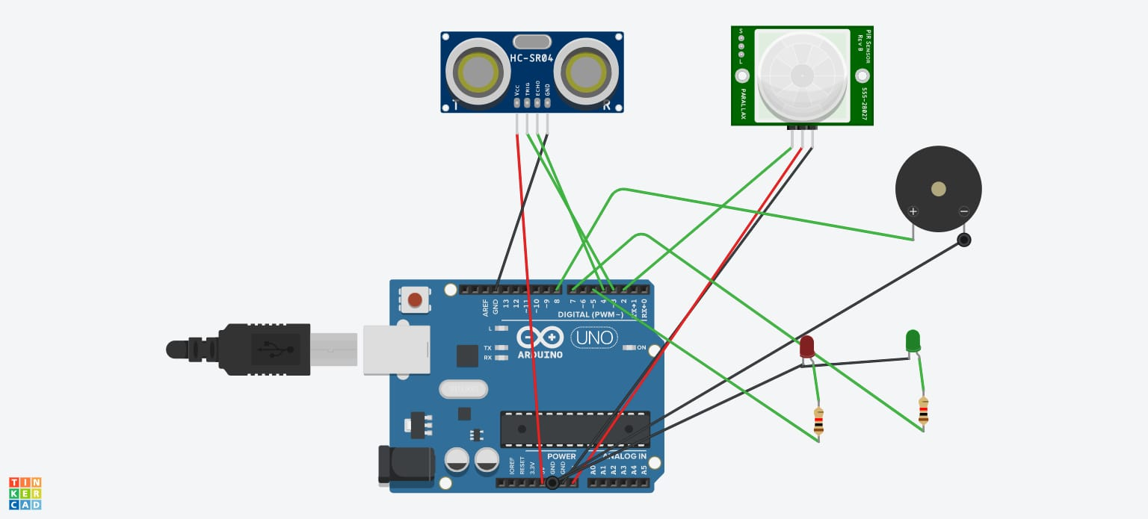

TINKERCAD LINK:

https://www.tinkercad.com/things/8ean4FP2wmd-epic-bruticus-allis/editel?tenant=circuits